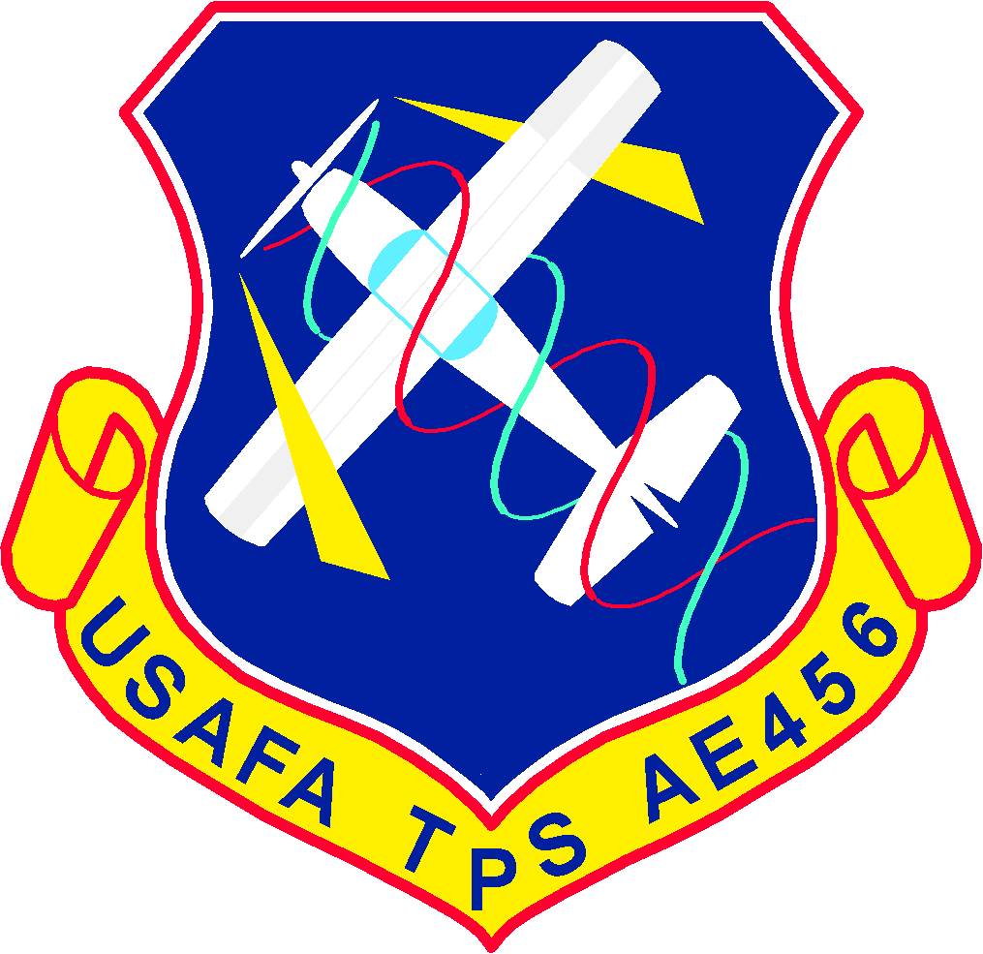



This technical report (AE456-TR-T41D-P-Team AJP + DS, T-41D Takeoff, Cruise, & Pitot-Static Performance Limited Evaluation) was submitted under authority of the AE 456 Flight Test Techniques Course by the Department Head, Department of Aeronautics, Department of Faculty, US Air Force Academy, Colorado, 80840-6222.

The following collaboration statement applied to the work contained herein:

| For this assignment, you may work with the following persons, in addition to an instructor in this course: **the member of your assigned team**. For this assignment, you may use the following materials produced by other cadets: **raw data from other T-41D flight test sorties flown in the current semester.** Each team member is responsible for the content and quality of the entire assignment submitted. Your grade on this assignment will be based on your instructor's assessment of your original effort. |
| --- |

**Documentation:** Collaborated w/ other AE456 students to create a t-distribution for T/O data. Clarified figure formatting and performance concepts w/ LtCol Robarge and received explanations about how to better create figures in flight test.

**Prepared by: This report has been reviewed**

and is approved for publication

**3 Feb 2022**

______________________________ _________________________

DAVID SONG TYLER W. ROBARGE

Cadet, USAF Lt Col, USAF

Test Conductor AE 456 Course Director

______________________________ _________________________

ANDREW J. PUTLOCK DOUGLAS P. WICKERT

Cadet, USAF Col, USAF

Test Director Permanent Professor & Head

Department of Aeronautics

##### INTRODUCTION

**BACKGROUND**

A limited performance evaluation of the T-41D was conducted in the areas of take-off performance, pitot-static systems, drag and power characteristics, cruise performance, level sustained turn performance, climb performance, and glide performance. These tests were conducted on behalf of the USAF to evaluate the T-41D’s ability to succeed as a preliminary trainer at USAFA. Flight Test 1 was conducted on 24 January 2022 with takeoff roll beginning at 0735:25L. It consisted of 1 sortie totaling 1.4 hours and was flown at KAFF inside Local Area 4. The weather was clear, with winds at 010/08, 6582 PA, and surface conditions of -8C. Lt Col Robarge sat in the front left seat as TP, C1C Song sat in the front right seat as the TC, and C1C Putlock sat in the rear seat as TD. Flight Test 1 collected data to evaluate the T-41D in the areas of take-off performance, pitot-static systems, and drag and power characteristics.

**TEST ITEM DESCRIPTION**

The Cessna Manufacturing Company’s T-41D “Mescalero” is an all metal, single-engine, strut balanced high wing monoplane. It contains a Continental

Tails, take off weights , instrumentation used ....

Develop a concise test item description that includes general details in the first paragraph (those items that apply to all T-41Ds) and specific details in the second paragraph (items particular to your aircraft). Write in a detailed manner, I want specifics. The specific details, however, should only highlight those characteristics relevant to the type of flight tests conducted. Highlight Performance items for flights 1 and 2, and FQ items for flights 3 and 4. Did the test item have any flight test modifications? Clearly state if the test item is production representative, prototype, or modified from the production configuration. Be sure to direct the reader to a more detailed source of information about the test item, like the Flight Manual (Reference X), Modification Flight Manual, or other reference. Hint: start with the test item description in your Test Plan; however, this needs to be amplified as appropriate.

**LIMITATIONS**

The most impactful limitation was the DAS. The DAS only recorded data up until the beginning of takeoff roll, so no DAS data was collected to use the GPS FTT to determine takeoff ground roll distance. DAS data from the other AE456 flight tests will be used to determine takeoff ground roll from the GPS FTT. Additionally, cadet inexperience with the T-41D instruments resulted in inaccurate fuel remaining measurements for the Thrust Required FTT, resulting in a correction in the data post-flight.

##### TEST AND EVALUATION

**OVERALL TEST OBJECTIVE**

Evaluate the suitability of T-41D for the preliminary trainer mission at USAFA.

**DETAILED TEST OBJECTIVES**

| **Test Objective 1** | **Evaluate Takeoff Performance** |
| --- | --- |
| **MOP 1-1** | **Takeoff Ground Roll** |
| **Test Objective 2** | **Evaluate Pitot-Static System** |
| **MOP 2-1** | **Pitot-Static Error Correction** |
| **Test Objective 3** | **Determine Power and Drag Characteristics** |
| **MOP 3-1** | **Power Required** |
| **MOP 3-2** | **Drag Polar** |
| **Test Objective 4** | **Evaluate Cruise Performance** |
| **MOP 4-1** | **Cruise Endurance** |
| **MOP 4-2** | **Cruise Range** |

**OVERALL TEST METHODS AND CONDITIONS**

No-flap, Mixture - full rich, Max Prop RPM - 2,600 RPM (except takeoff, where the prop is set to full increase IAW T.O. T-41D-1). Target altitude of 10,000 feet PA (except takeoff where PA is ambient PA on takeoff roll). If weather or other circumstances preclude taking data at 10,000’, the pilot may choose a new target altitude in-flight and continue the profile. Note: no data will be collected at less than 1,000’ AGL. NOTE: Data will be corrected from Day-Of test conditions to those required to assess evaluation criteria

**TEST OBJECTIVE 1 – EVALUATE TAKE-OFF PERFORMANCE**

**Measure of Performance (MOP) 1-1**: Take-off Ground Roll distance.   
  
Takeoff ground roll is defined as the distance from brake release (engine stabilized at max power) until main landing gear liftoff.

**Test Methods and Conditions:**

The takeoff was defined as the distance from brake release (engine stabilized at max power) until main landing gear liftoff. All takeoffs were no-flaps, from a static takeoff. After recording stabilized engine data at full power while holding brakes, the recording began a brake release. The key airspeeds were 60 KIAS at rotation and the liftoff A/S. The TC was in charge of flopping the DAS and counting runway stripes and spaces, while the TD was timing the ground roll using a stopwatch. The TP’s focus was executing a perfect takeoff, while reading and remembering rotation and liftoff airspeed.

**Evaluation Criteria:**

Table 1: Evaluation Criteria for Takeoff

| **Criteria**  Takeoff ground roll (feet) | **Rating** |
| --- | --- |
| < 2,200 | Satisfactory |
| 2,200-2,500 | Marginal |
| > 2,500 | Unsatisfactory |

The ground roll distance is corrected to and evaluated for the following conditions: 9,000’ DA, maximum gross weight (2,550 lbs), zero wind, zero slope. The criteria is to be assessed with 95% confidence that all take-offs (at the above conditions) meet distances in the table above.

**Test Results:**

From the hold short line, test members collected the runway temperature, PA, and winds. The static run-up to max RPM (2775 rpm) and flaps up took place lined up on the left of the 1st stripe on runway 34R. The offset in centerline was for the TC to be able to count runway stripes and dashes. TD and TC observed a MAP of 21.2, and 45.3 gal fuel remaining during the static run-up as well. On brake release, TC flopped DAS 90° and TD started the stopwatch at 14:35:25Z for the GPS Integration and the Average Acceleration methohds, respectively. TP tapped the left wheel brake to correct centerline, but there is nothing else non-standard to report. Upon liftoff callout by TP, TC continued to watch the ground and counted 7 stripes and 8 spaces, resulting in a visual estimation method result of 1480 ft. TD stopped the stopwatch at TP “liftoff” callout at 14:35:49Z, resulting in a 23.77 sec ground roll. TP watched AS indicator and observed rotation at 60 KIAS and liftoff at 64 KIAS. The DAS data cut out the liftoff and most of the brake release, giving the team no option to get accurate GPS data. In the end, the only usable methods using our team’s data were the Average Acceleration and the Visual Estimation methods. Using all data that was not omitted, between 6-9 flights were used to create the 95% confidence interval. The Average Acceleration Method achieved a **MARGINAL Rating** with a 95% confidence interval of 2415 ft with 9 flights. The GPS Method’s 95% confidence interval was 2988 ft with 6 flights. The GPS Method therefore showed that the T-41 Takeoff performance is **UNSATISFACTORY.** Finally, the Visual Estimation Method resulted in an **UNSATISFACTORY** rating. The Visual Estimation used all 9 flights and had a 95% confidence interval of 2834 ft. Refer to Table 1 for the evaluation criteria.

**TEST OBJECTIVE 2 – EVALUATE PITOT-STATIC SYSTEM**

**Measure of Performance (MOP) 2-1**: Pitot-Static Error Correction

**Test Methods and Conditions:**

Using the GPS Pitot-Static Error FTT entails using the GPS as a truth source and flying at least three headings to obtain the difference between the observed KIAS on the instrument panel and the KCAS obtained from a truth source. The data collected on each leg was KIAS, PA, OAT, GPS Ground Track, and GPS G/S.Cardinal headings were used to simplify execution and data reduction, but it is essential to the data that test officials do not take data readings immediately after getting on the heading to minimize the effects of GPS lag. The technique used was waiting at least 10 seconds after shacking airspeed to obtain an accurate reading. Another helpful technique was using the long and perpendicular country roads in the area as guides in heading.

**Evaluation Criteria:**

Table 2: Evaluation Criteria for GPS Pitot-Static Error FTT

| **Criteria** | **Rating** |
| --- | --- |
| Max error magnitude ≤ 3 knots  in the range 60-80 KIAS  Max error magnitude ≤ 5 knots  in the range 81-105 KIAS | Satisfactory |
| ELSE | Unsatisfactory |

**Test Results:**

TP flew each A/S sequentially in the area and informed the TC/TD when the KIAS stabilized. After waiting at least 10 seconds for the plane to stabilize, the TC/TD recorded the KIAS, altitude, OAT, and the track and ground speed of 4 roughly perpendicular legs required to run data reduction post flight. The TC tracked the OAT, and both the TC and the TD were in good positions to read the dash board that had GPS data and G/S. The TP called out the KIAS and PA before the maneuver and after the GPS stabilized. Using the Pitot Static Testing - GPS Method Data Reduction Excel spreadsheet, the data is shown in Table 3.

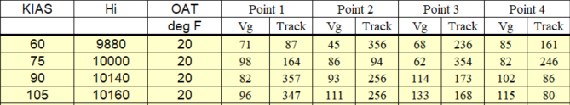

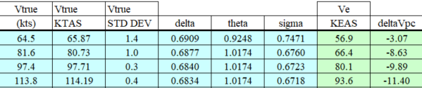

Figure 1: Results from GPS Method Data Reduction Excel spreadsheet

As Table 3 shows, the pitot-static system does not satisfy the evaluation criteria in Table 2. Therefore, the pitot-static system was rated **UNSATISFACTORY.**

**Recommend performing GPS Pitot-Static Error FTT with additional airspeeds at 55, 65, 70, 80 KIAS (priority order) (R2).**

**MISSION SUITABILITY** New Page

The T-41D was found to be SUITABLE in the area of Takeoff Performance. Although the T-41D only got a MARGINAL and UNSATISFACTORY ratings based on the evaluation criteria, the evaluation criteria may have been too conservative. The dimensions of Runway 34L are 3534 x 75 ft

Following paragraphs detail the mission suitability of the test item in the specific areas tested, one area at a time. Start each paragraph with a statement like: “The T-41D was found to be SUITABLE/UNSUITABLE in the area of Takeoff Performance”. Now say why. This is not a place to simply restate the test results and eval criteria. Interpret the performance in light of its ability to do the mission. Test data and eval criteria are helpful to inform your opinion. You are using your vast experience as a pilot/engineer to assess if the aircraft can accomplish the mission intended, in the context intended.

Compare the takeoff distance to the runway length available. Look at the acceleration (and total time spent on the runway). Compare to other aircraft used for this mission. Now consider the pilots (and student pilots) that will be flying the plane. Considering their experience level, how do these numbers contribute to a safe training platform, or not. This should be a detailed look at how the aircraft accomplishes the assigned mission. Consider the results from each T+E section, and bring it to bear on the discussion. You should only cite final results in this section, as opposed to the detailed data reduction and minutia discussed in the previous parts of T+E. Your analysis is independent of Mil-Spec paragraph pass/fail or lack of agreement between your results and the Flight Manual.

This is ONLY a discussion of how well the aircraft performs the assigned mission(s). **The aircraft can fail an eval criterion and still be suitable!** Again, the key is to discuss how each area tested impacts the aircraft’s ***suitability*** to do the specific mission you are evaluating it against.

##### APPENDIX A – GRAPHS

Refer to the plot below as an example. I recommend you make a plot that looks like the example and save it as a template in Excel – that way it’s much easier to utilize it throughout this course.

Graphs should be **stand-alone**, meaning if someone prints out only that page and takes it to a meeting, it makes sense. Label key points on the plot such as minimums, maximums, etc. Make sure the units on the axes are correct. **INCLUDE A HEADER BOX AT THE TOP** (shown below)

**NEVER USE YELLOW SYMBOLS OR PLOT LINES**

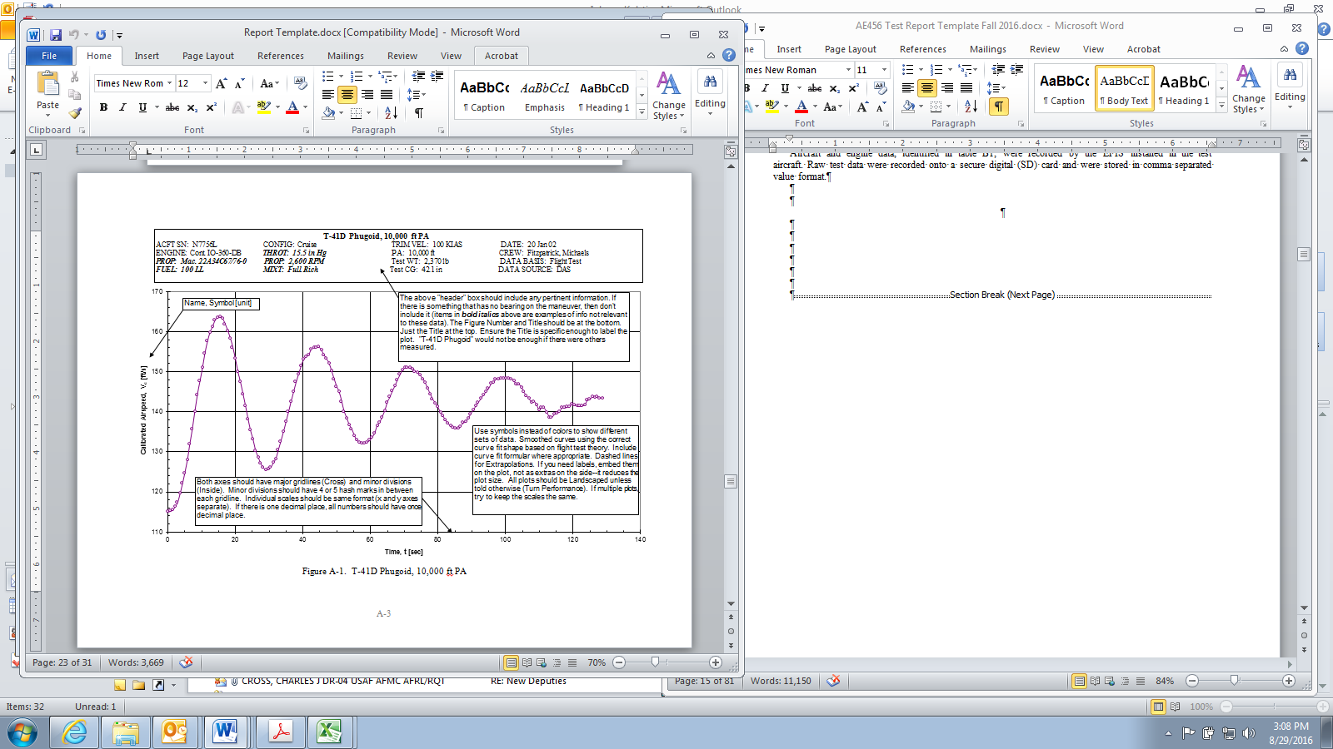

1) From Excel, copy the selected graph (complete with x & y axis titles) into the buffer, then switch to the appropriate page in Word.

2) Put the insertion point in front of the paragraph symbol immediately below the graph header data (right justify the paragraph).

3) Select “Edit,” “Paste Special...,” “Picture.” (be sure the “Float Over Text Box” is not checked)

4) Stretch the upper left corner picture toggle until the right edge of the graph aligns with the right margin.

5) After you’ve completed steps 1-4 and deleted this text, be sure the figure title ends up approximately 1” above the bottom of the page (as it is shown here).

This page was intentionally left blank

##### APPENDIX B – FLIGHT TEST DATA-DON’T NEED

*Scan**your test cards from the flight and upload them to your semester’s Team’s site in a folder specific to your group. Also include your two Daily Flight Reports. This section of the report can just state the following:*

“Raw data for each referenced flight can be found at the following URL: ________________”

This page was intentionally left blank

##### APPENDIX C – DATA REDUCTION-DON’T NEED

*Upload the spreadsheets, MATLAB scripts, or any other methods you used for data reduction into the same folder you used for Appendix B. Don’t worry about making the spreadsheets pretty – I’ll contact you if I’m having trouble following something. This section of the report can just state the following:*

“Data reduction tools for this report can be found at the following URL: ________________”

This page was intentionally left blank

##### APPENDIX D – LIST OF SYMBOLS AND ABBREVIATIONS-DON’T NEED

Note: List all of the ones you use and delete the ones you don’t.

Guide: if an English Major has a question on it, include it here.

**Start with those from the test plan and add and delete as required**

This page was intentionally left blank